**PROJECT 1:**

Deploying a web server in Windows instance

IP Address:- 3.131.95.62

**Screenshots**

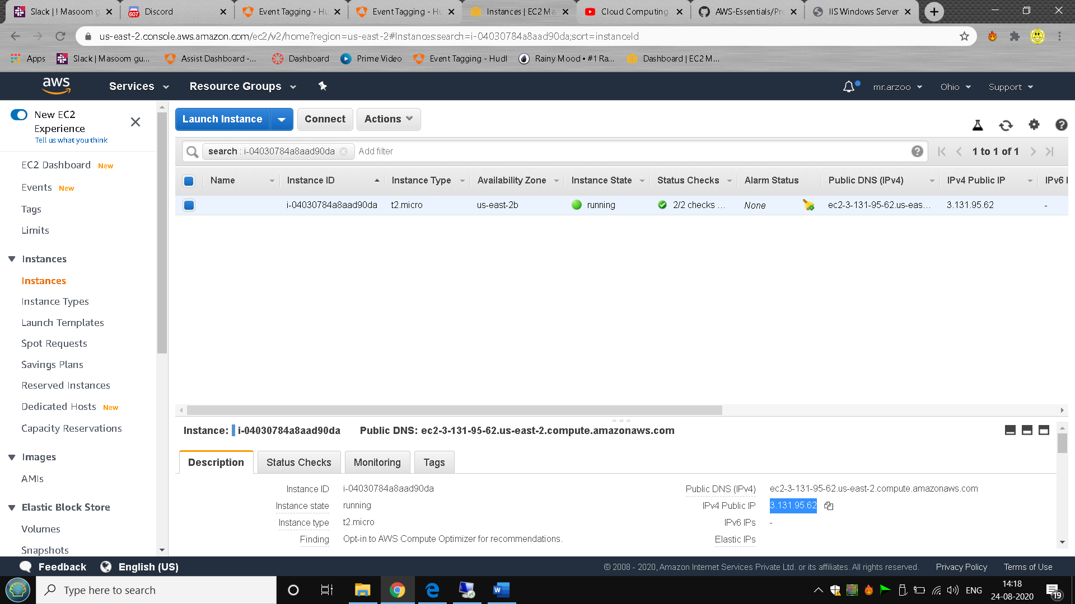

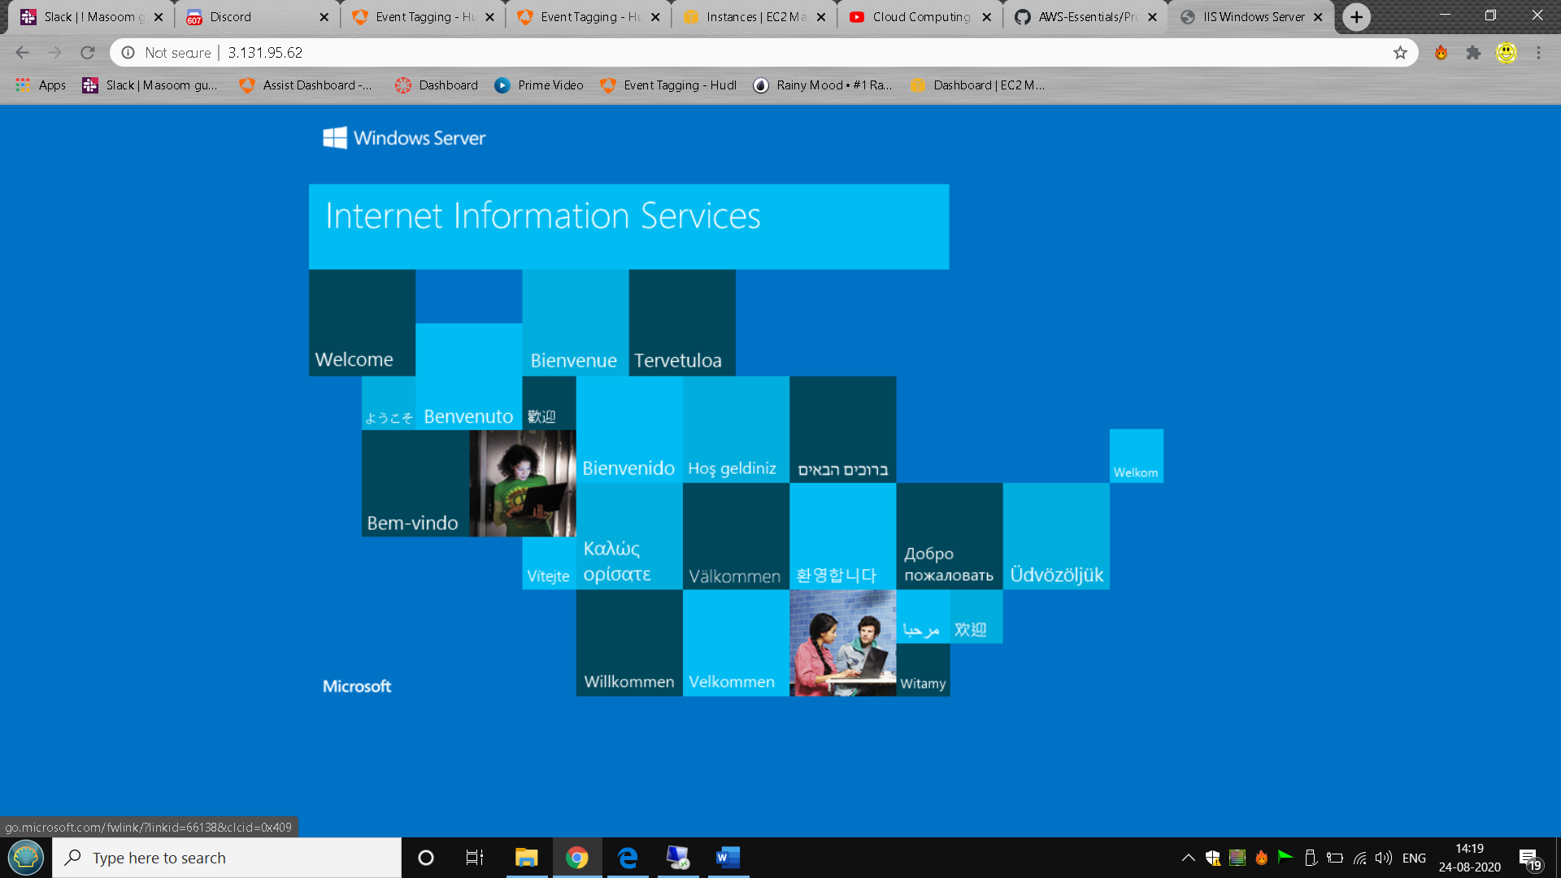

**PROJECT 2:**

Deploying a web server in Windows instance

IP Address:- 3.12.84.140

**Screenshots**

